**Final project data analysis**

**Abstract.** In this paper, Jiyoon (Clover) Jeong and Jin Kweon are trying to inspect the official FIFA 2017 data. Our goal is to find out how the FIFA ratings on the players were decided. The better rating indicates how valuable the players are. We were curious whether the rating well indicates the players’ stats. Our data contains 17588 players with 53 different variables.

***Executive summary:***

* Our team has believed that FIFA rating has been somewhat biased, and we decided to inspected 17588 players’ ratings that we downloaded from Kaggle.

* We decided to whether ratings are different based on positions and preferred foot of the players with Two-way MANOVA, how quantitative variables are related with the rating with linear regression, and find how each variable is correlated each other with PCA.

* We found that FIFA ratings are not 100% fairly evaluated and it is better for people not use FIFA ratings to compare players with different positions. So, FIFA ratings should be used to compare players in the same positions.

***Background:***

Two of us have pretty solid prior knowledge of soccer, and we used some of our intuitions when we do analysis. For example, When we do test out the PCAs, it is possible for us not just test all the quantitative variables, but select some of the variables that we thought would be reasonable to test. (which is more efficient)

Another important thing we decide to do for our analysis is to focus on clubs. Players play either on their national team or clubs. And, it is definitely possible for players to play for different positions and kit number in national and clubs. That way, it makes much harder for us to analyze and draw conclusions if we consider both. As players are selected to represent their countries based on their performance in their teams and players spend much more time in clubs, we decide to let players’ club profiles as our major variables. (however, depends on the situation, we used national information, and we are going to explicitly say it if so.) Also, please refer to appendix for the R codes.

**1.** **Introduction**

***a) Problem (the question I want to address)***

**1. We want to know how the ratings (and ages) are different based on club positions (goalkeeper, defense, midfielder, attacker) and preferred foot of the players.**

Reason: There has been enough arguments that FIFA has brought more and unfair attentions onto attacker (sometimes, midfielder as well), and other positions are treated/rated unfairly. And, we want to check whether the argument is true. Also, we are just curious how ratings are different amongst the players with different preferred foot. (also at the same time, the variable “Age” is really important to soccer players, so I want to include this for our quantitative variable. And, we assumed ratings and ages are closely related.)

Hypothesis: The means for each group of position-effect, preferred-foot-effect, and interaction are the same.

Aim/objective: I need to use “two-way MANOVA.”

**2. We are going to find out what quantitative variables are related with the rating.**

Reason: It is reasonable to assume that the overall ratings of professional soccer players are proportional to their score variables such as ‘Weak_foot,’ ‘Skill_Moves,’ ‘Ball_control,’ … , ‘GK_Reflexes.’ We want to see how ratings are changing when each predictors are changing by linear regression and transformation of variables.

Hypothesis: There should exist some quantitative variables that have a linear relationship with rating.

Aim/objective: Detect the predictors which have strong linear relationship with variable ‘Ratings’ and find proper transformation of variables if needed.

**3. I want to test how much each variable is correlated with the rating. PCA will also help me find co-linearity issue.**

Reason: We aim to find PCs to best summarize the variables, and see how players’ rankings are plotted.

Hypothesis: Different positions have different variables correlated with the rating, and I should find the skills that are important to the position should have high correlation with the rating.

Aim/objective: I hope to make good interpretation of the components to explain the the relationships between variables, and eventually help us how rating can be explained by other variables.

***b) Data (summary of the data, the study design, data collection)***

We collected our data in Kaggle website (please refer to the reference). The original data has 17588 rows and 53 columns.

It is important how we sample the data. Players are selected to play in the national team if they perform well in the club. It is true nowadays in the soccer world, players spend more time playing for the club. So, we are focusing on inspecting players’ club profiles only. Although national related information is not our major variables, we our not going to take them out, as these information help us as some of the players do not have enough club informations. In this case, we replace empty club information with national information. For example, many players do not have specific positions (“Sub,” “Res,” and empty) for their clubs, and we tried to find these missed informations from their national positions, if possible. Whenever we do analysis that has to do with positions, we needed to work on the extracted samples of the size 3656, as the others do not show clear positions.

We examined the raw data and found that variable ‘National_Position’ has 16513 missing values and variable ‘National_Kit’ has 16513 NA values. Variable ‘Club_Position,’ ‘Club_Joining,’ ‘Contract_Expiry,’ and ‘Club_Kit’ has one missing/NA value which at 384th observation. (data dictionary: <https://github.com/yjkweon24/public-health-245/blob/master/dictionary.csv>)

**2.** **Methods**

***a) Method (my choice of model, analytic method, why)***

**1. Multivariate test:**

Our subject will be 3656 soccer players: around 20% of our entire set. (but different groups of population) The quantitative variables are ratings and ages (and as we assume ratings and ages are somewhat closely related, we can say that our measurement is generally just ratings. Intuitively, for most of the cases, it is true for ratings and ages. To prove my points, we draw the linear model, component plus residual plot, and get correlation, and we found out they are pretty correlated. Again, this is not 100% correlated, but I assumed to be), and there are 2 factors: club positions (4 levels - goalkeeper, defense, midfielder, and attacker) and preferred foot (2 levels - left and right). So, I need to use Two-way MANOVA. Our team decides to conduct this test to see if there any difference of means from many groups.

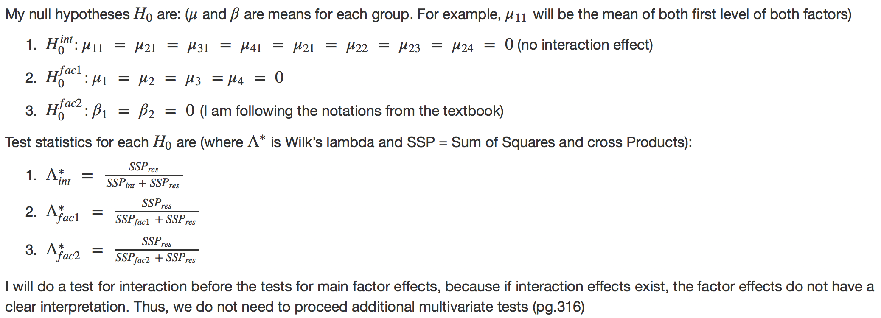Our conclusion is that we reject all of three null hypothesis. (p-values are all pretty small, meaning all are less than 0.05) Thus, there is position effect, preferred foot effect, and position-preferred foot interaction effects on ratings (based on the assumption that ratings and ages are correlated well enough), meaning that the means for different groups are different. So, we can say that it is likely that different positions and different preferred foot make different ratings.

**2. Linear regression:**

We will use linear regression coefficients, T-test, and F-test to find which predictors (quantitative and qualitative variables in factors) contributed significantly in determining ratings by regressing variable Rating on other explanatory variables.

First, we used lm function and fitted a linear regression model using rating as the response and other variable as the predictors and check significant predictors & t-test for significance of each variable.

We converted Height and Weight variable into numeric variable and fit a linear regression model using Ratings as the response and the all other quantitative variables as the predictors. The summary of this fit shows interesting result. We expected that the most of the score variables (‘Weak_foot,’ ‘Skill_moves,’ …. , ‘GK_Reflexes’) will have at least 0.01 significance in the beginning. However, the lm() function results clearly shows that only 10 variables are strongly related to their ratings(T test). If we set significant level as 0.001, variable ‘Skill_Moves,’ ‘Ball_Control,’ ‘Reactions,’ ‘Attacking_Position,’ ‘Composure,’ ‘Short_Pass,’ ‘Heading,’ and ‘GK_Handling’ are significant among 41 predictors. The first and the second plot below shows the relationship between variable ‘Reaction’ and variable ‘Composure,’ which are the two most significant variables when we build a linear model with the response variable ‘Ratings.’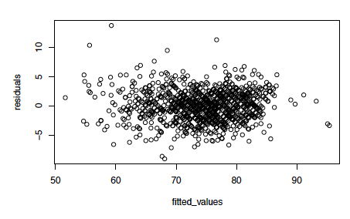

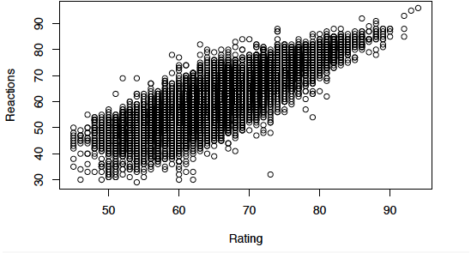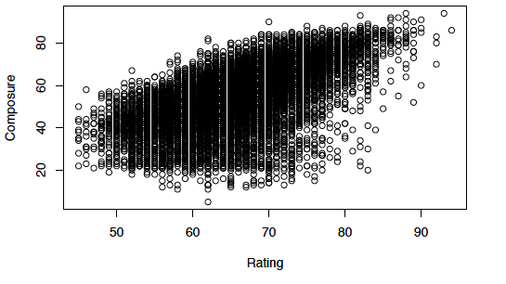

From the first and the second plots, we can see that these variable shows clear linear relationship between themselves and the response(Ratings). We also drawed a residual plot(the third one from above), with the fitted values on the x-axis, and the residuals on the y-axis to check if there is any violation of assumptions of the linear model. (linear or not, variance constant, normal or not). The residual plot shows that it does not particularly violate linear model assumption since the residuals are symmetric to y = 0 axis and does not show specific patterns. Also, variance seems like a constant too. Next, we plotted of Cook’s distance and influential points to detect outliers.

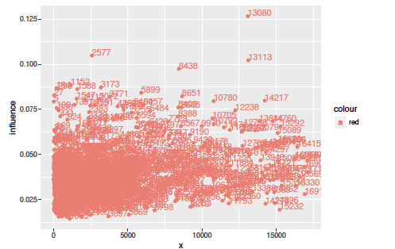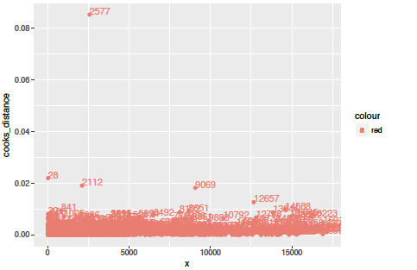

We can see that 2577th, 28th, 2112, and 13080th observations are potential outliers and influential points so removed those points and fitted again. The lm fit shows that the significant variables did not changed, and it suggests that the linear relationship between the significant variables that we stated in the beginning is still strong even though we removed potential outliers and influential points. In fact, the adjusted R-squared increased.

After we fitted all the players at the same time using lm function, we tried to fit lm function onto each position of the players since we wanted to know if FIFA rating has been somewhat biased to certain position as we stated in the executive summary. We divided club position into 4 types which are midfielder, goalkeeper, attacker, and defense. As our intuition, the significant variables for each club position were various from position to position.

We could see that in the summary (goalfit), the significant variables of goalkeeper are quite different than the significant variables of other club position. For example, goalkeeper position does not have strong linear relationship with ball control, short pass, and heading ability but all other three position (midfielder, attacker, and defense) have strong linear relationship with those predictors. This is intuitively true since goalkeeper’s most important ability is to block and catch the ball instead of passing and moving the ball to other players or to goal net.

**3. PCA:**

First of all, we performed the PCA with the correlation matrix. And, we used the 38 variables out of 53 variables, as PCA performs on continuous variables. (again, please refer to the data dictionary for more details)

We decided to use the first top five components - these five components’ cumulative percentage is around 82%. (based on the elbow on scree-plot, Kaiser, or Jolliffe’s rules, it is recommended to keep up to 7 components, but we will mostly use three - five components for most of our analysis.

Since we are using a huge data, the correlation unit circle and individuals on the PCA map are hard to be interpreted, so, we decided to also use the sample we cleaned (3656 players). To do better interpretation, we decided to rank the players based on the scores on the first three PCs.

The players placed on the top rankings for PC1 are “Paul Pogba,” “Cristiano Ronaldo,” “Arturo Vidal,” “Gareth Bale,” “Neymar,” “Luca Modric,” “Eden Hazard,” “Marco Reus,” “Thiago Alcantara,” “Paulo Dybala,” “Kevin De Bruyne,” “Alexis Sanchez,” etc. Compared to the players placed on bottom rankings, we could easily realize that PC1 indicates the “star” players. Although not all of them have super high ratings, they were “hot potatoes” in 2016 transfer markets. Please remember that the data is collected at the end of 2016.

For PC2, there are “Deulofeu,” “Ousmane Dembele,” “Riyad Mahrez,” “Nani,” “Paulo Dybala,” “Sergio Aguero,” “Neymar,” “Quaresma,” “Messi,” etc on the top rank. By looking at the players’ stats, we could see that PC2 might indicate the stats of dribbling and assisting.

PC3 has “Manuel Neuer,” “Gianluigi Buffon,” “Petr Cech,” “De gea,” “Samir Handanovic,” Claudio Bravo,” “Ter Stegen,” “Toni Kroos,” “Luis Suarez,” “Zlatan Ibrahimovic,” “Michael Carrick,” “Raul Garcia,” “Bastian Schweinsteiger,” etc on the top ranks. And, it is easy to see that most of them are either good goalkeepers or equipping good stamina (compared to the players in their own positions).

Lastly, we want to see how the variables are correlated, so we made the correlation circle between variables and PCs. (we only showed PC 1 v.s. PC2, here)

Based on what we could see from correlation circles (we also inspected PC1 v.s. PC3 and PC2 v.s. PC3), “ratings” are taking popularity into account. However, the positions, ages, and strength itself are not the important facts for ratings. However, all other skills such as jumping, heading, agility, agility, vision, etc are important factors, for most of the players. On top of that, some of the variables might not be important for some players, but that could be really important on some players’ ratings. For example, the variable “Position” itself does not have huge influence on ratings; however, based on players’ positions, the way how the rankings are assigned to the players are different. (for example, players who are on the top on PC3 have high composure, vision, reading, long passing, strength, age, but they do not necessarily have accelerativity and agility) Furthermore, our correlation circles and PCs will be different if we perform extra-analysis on each position. 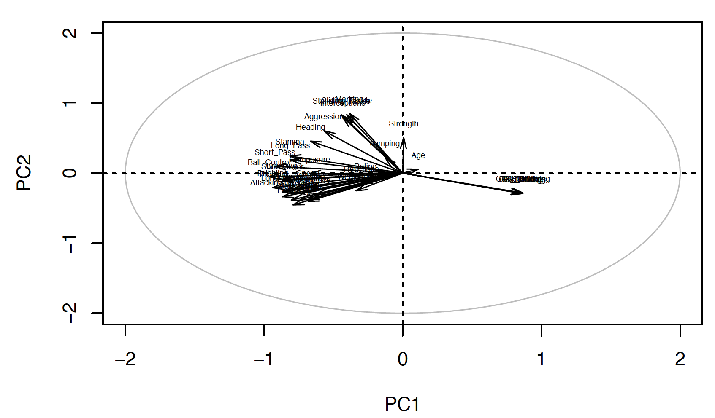

Last but not least, based on what we found from PCA, there could be multicollinearity issues arose, as many variables are often related each other. For example, the variables “Acceleration” and “Agility” are really correlated, so we could take one out.

**3.** **Result and Summary**

***a) Results (summary of numerical analysis, interpretation, assumption check)***

Multivariate tests:

Our conclusion is that the mean of ratings are different based on different positions, preferred foot of the players, and interactions of these two.

Linear regression:

Linear regression using all quantitative variables shows us that there are particular variables which are linear related to rating for each players. For overall ratings, the summary of lm funtion’s fit of full model suggests that variable Skill_Moves, Ball_Control, Reactions, Attacking_Position, Composure, Short_Pass, Heading, and GK_Handling have strong linear relationship with ratings. As our assumption in the beginning of the analysis, we found that FIFA rating is in favor of the players who serve attacking position since variable Attacking_Position much more significant than other predictors.

However, as we shown in the last analysis in linear regression part, we gain fairly different results for significant predictors by club position. Especially the lm function’s fit from the data consists of players who have goalkeeper position shows quite different significant predictors than the other three positions. It suggests that FIFA assess goalkeeper’s rate quite differently than the other position.

PCA:

There are different variables affecting FIFA ratings, and these can be really different based on positions and the types of players. (the players who are in the same “type” are not necessarily in the same positions, but in similar rankings on some PCs)

***b) Conclusion***

Our goal was to find out how the FIFA ratings on the players were decided. We were curious whether the rating well indicates the players’ stats.

We concluded that the ratings were not evaluated 100% fairly (for example, we found that the ratings put more weights on forwards and star players), but they were good scales to show how good the players were in overall if they are the same type (two players can be regarded as dribblers but one can be midfielder and the other can be attacker) and positions. We found that it was not a good idea for FIFA to compare players in different positions/types and rated them together. They might be able to improve the index as to create separate ratings for different positions.

***c) How it can be further developed***

In our analysis, the variable “Position” is doing an important role. We get the samples based on the players who can be categorized into four big positions, and we sometimes separate the data into these four positions, and work on another analysis, to see how the each position behaves on ratings. Some other groups might be able to go into deeper based on other variables.

We separate data into four big positions, and this is pretty decent categorization. However, this might need further improvement for better analysis. It is because every team has different tactic and philosophy, and player positions can be more complex than what it is. For example, RWB (right wing back) players are required to play as midfielder and even attacker for some teams. One great example you could find if you are interested in: <https://en.wikipedia.org/wiki/Total_Football>. So, our grouping is arbitrary, and this can be different.

Also, remember that most of the data seems like coming from the players playing in European leagues. This can be further developed, when we can collect all the players’ statistics in every continent.

**References**

<https://www.kaggle.com/artimous/complete-fifa-2017-player-dataset-global>

**Appendix**

Please refer to the link for the R codes: <https://github.com/yjkweon24/public-health-245/blob/master/code/project%20(Jin%20Kweon%2C%20Jiyoong%20Clover%20Jeong).Rmd>